GOVERNMENT TECHNICAL INSTITUTE (POL)

Department of Information Technology
(IT-DP 2505) Web Design II

A.G.T.I Second Year (Semester IV)

Submitted by
Sign
Name:Ma Shar Thet Han
Roll no: 2GIT-10

JOB-1(BMI Calculator)

<!DOCTYPE html>
<html >
<head>
<meta charset="UTF-8">

<title> Document</title>
</head>
<style> body{
background-color: blueviolet;
}

button{background-color: yellowgreen;margin-left: 8rem;margin-top: 2rem;

}
.three{
padding-left: 5rem;
}
</style>
<body>
<h1>BMI Calculator</h1>
<div class="one">
<label for ="Height">Height in (in):</label>
<input type="text" name="height" id="height"><br><br>
<label for ="Weight">Weight in (lbs):</label>
<input type="text" name="weight" id="weight"></div>
<div class="two">

<button type="submit" onclick="Calculation()">Calculate</button></div>
<div class=" three">
<h1> BMI Weight Guide</h1>
<p>Under Weight=Less than 18.6</p>
<p> Normal Range=18.6 and 24.9</p>
<p> Over weight= Gerater than 24.9
</p>
</div>
<script>
function Calculation(){
var height=document.getElementById('height').value;
var weight=document.getElementById('weight').value;
result=703*(weight/(height*height));

if(result<18.6){
window.alert(result+"\n U are under weight");
}
else if( result<=18.6 && result>=24.9){
window.alert (result+"\n You are normal weight");
}
else{
window.alert(result+"\n You are over weight.");}
}
</script>
</body>
</html>

BMI-Calculator (output)

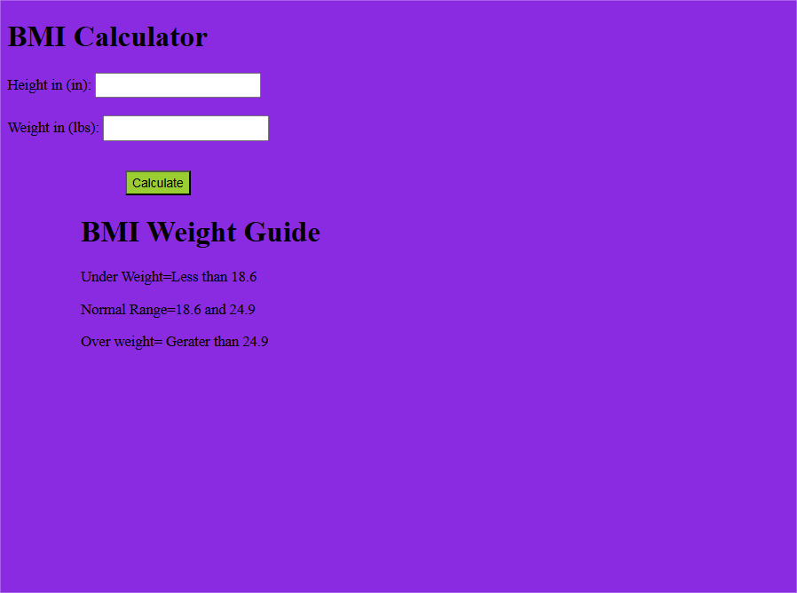

When test over weight:
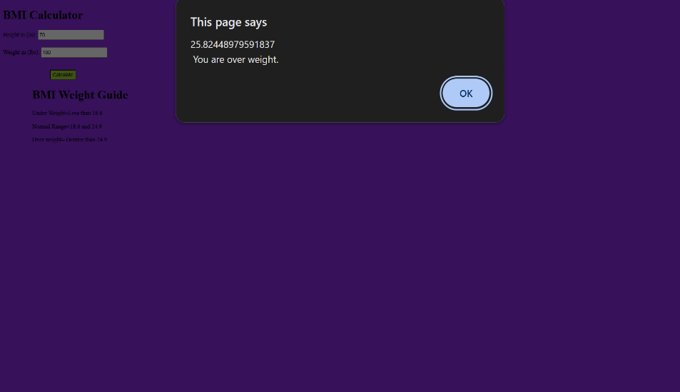

When test under weight:
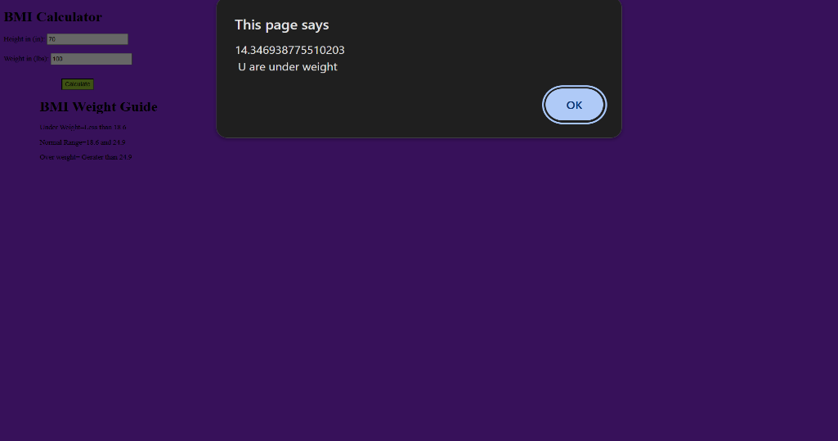

JOB-2(Change Background Colour)

<!DOCTYPE html>
<html>
<style>
button{
padding: 10px 20px;
margin: 5px;
cursor: pointer;
}
.pink{ background-color: rgb(68, 17, 17);}
.yellow{background-color: rgb(89, 89, 85);}
.blue{background-color: rgb(254, 254, 255);}
.pink:hover{
background-color: rgb(135, 82, 120);
}
.yellow:hover{
background-color: rgb(38, 22, 2);
}
.blue:hover{
background-color: rgb(100, 157, 157);
}
.image-text {
display: flex;
align-items: flex-start;
gap: 10rem;
}
.image-text img {
display: block;
width: 300px;
height: auto;
}
.image-text p {
margin: 2rem;
text-align: right;
width: 1000px;
height: auto;
padding: 1rem;
background-color: lightgray;
border-radius: 5px;
}
h2{
text-align: center;
}
</style>

<body>
<script>
function changeColour(color) {
document.body.style.backgroundColor = color;
}

let image1 = "image/47743242-9fcc-4d5b-aff8-6bb2aafb702a.jfif";
let image2 = "image/Spider-Man fondo para pc.jfif";
let text1 = "Spider-Man is a fictional superhero appearing in American comic books published by Marvel Comics. Created by Stan Lee and Steve Ditko, he first appeared in Amazing Fantasy #15 (1962).";
let text2 = "Peter Parker, a teenager bitten by a radioactive spider, gains superpowers including agility, wall-crawling, spider-sense, and web-shooters that he created.";
let showingFirst = true;

function nextImage() {
if (showingFirst) {
document.getElementById("myimage").src = image2;
} else {document.getElementById("myimage").src = image1;
}
showingFirst = !showingFirst;
}

// Hover text functions
function hoverText() {
document.getElementById("mytext").textContent = text2;
}

function normalText() {
document.getElementById("mytext").textContent = text1;
}
</script>

<h1>Change background Colour</h1>
<button class="pink" onclick="changeColour('Red')">Red</button>
<button class="yellow" onclick="changeColour('grey')">Black</button>
<button class="blue" onclick="changeColour('whitesmoke')">White</button>
<br><br>

<h2>Spider-Man</h2>
<div class="image-text">
<img id="myimage" src="image/47743242-9fcc-4d5b-aff8-6bb2aafb702a.jfif" alt="Image" width="300" onclick="nextImage()">

<p id="mytext" onmouseover="hoverText()" onmouseout="normalText()">
Spider-Man is a fictional superhero appearing in American comic books published by Marvel Comics. Created by Stan Lee and Steve Ditko, he first appeared in Amazing Fantasy #15 (1962).
</p>
</div>
</body>
</html>
Output:
Step1.
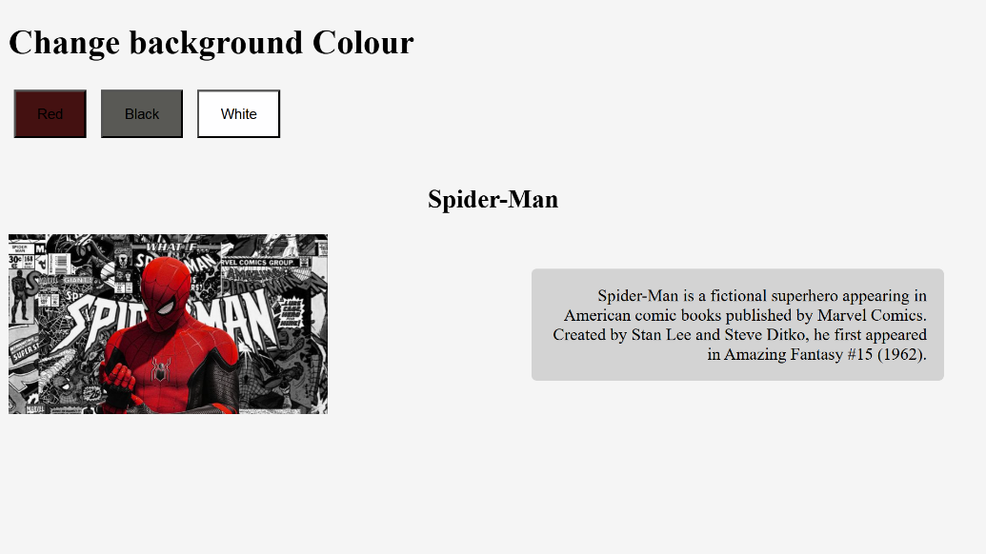
Step2. When click the Red Button ,the background is change to red colour
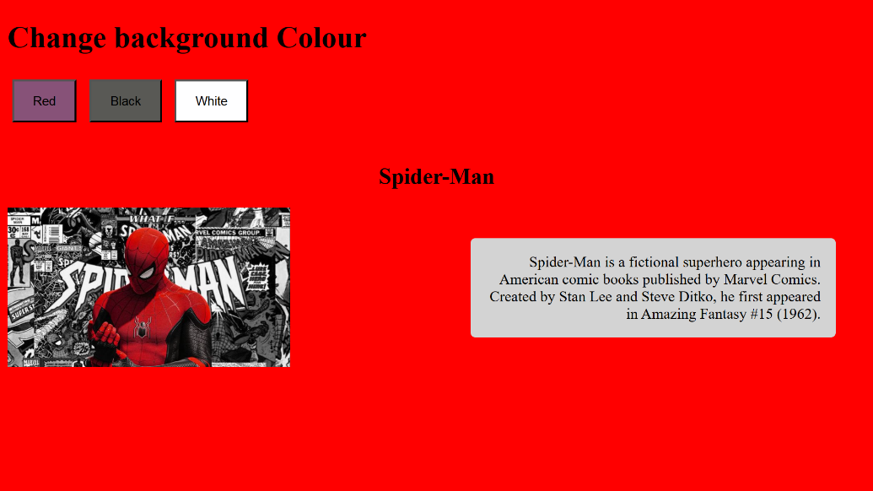
Step3.When click the image, the image is change another image
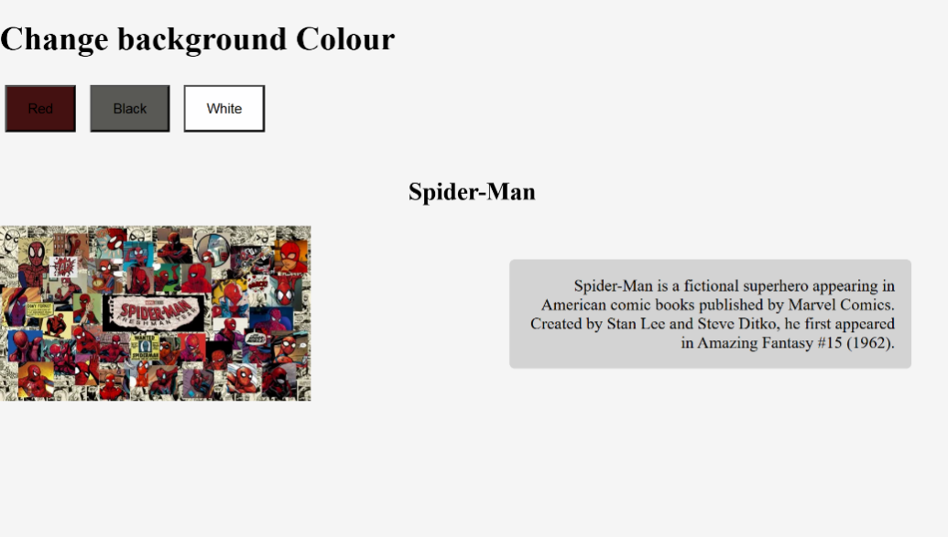
Step4.When hover on text box, text is change another text
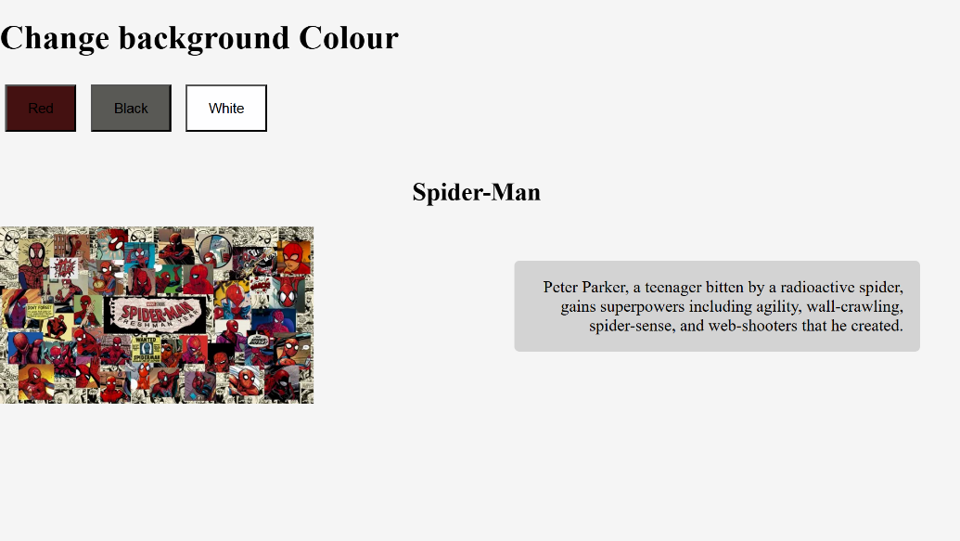

JOB_3(Application Form)

<!DOCTYPE html>
<html>
<head>
<meta charset="UTF-8">
<title>Simple Form</title>
<style> h1{
margin-right: 5rem;text-align: center;
}
.button{
text-align: center;

}
.button input[type="submit"]:hover,
.button input[type="button"]:hover {
background-color: #5a0645;
}
.row {
display: flex;
gap: 20px;
}
.row div {
flex: 1;
}

body{
background-color: rgb(248, 188, 216) ;
}

.required {
color: red;
font-weight: bold;}
</style>
<script>
function validateForm() {
let name = document.getElementById("name").value.trim();
let genderMale = document.getElementById("male").checked;
let genderFemale = document.getElementById("female").checked;
let nrc = document.getElementById("nrc").value.trim();
let dob= document.getElementById("dob").value.trim();
let nationality = document.getElementById("nationality").value.trim();
let religious= document.getElementById("religious").value.trim();
let address = document.getElementById("address").value.trim();
let email = document.getElementById("email").value.trim();
let phone = document.getElementById("phone").value.trim();

if (name === "") { alert("Name cannot be blank"); return false; }
if (!genderMale && !genderFemale) { alert("Select gender"); return false; }
if (nrc === "") { alert("NRC cannot be blank"); return false; }
if (dob === "") { alert("dobcannot be blank"); return false; }
if (nationality === "") { alert("Nationality cannot be blank"); return false; }
if (religious === "") { alert("religious cannot be blank"); return false; }
if (address === "") { alert("Address cannot be blank"); return false; }
if (email === "" !email.includes("@")) { alert("Invalid email"); return false; }
if (phone === "" isNaN(phone) phone.length < 7 phone.length > 11) {
alert("Phone must be 7–11 digits"); return false;
}

// new window show info
let newWin = window.open("", "_blank");
newWin.document.write("<h2>Submitted Information</h2>");
newWin.document.write("Name: " + name + "<br>");
newWin.document.write("Gender: " + (genderMale ? "Male" : "Female") + "<br>");
newWin.document.write("NRC: " + nrc + "<br>");
newWin.document.write("DOB: " + dob + "<br>");
newWin.document.write("Nationality: " + nationality + "<br>");
newWin.document.write("Religious " + religious+ "<br>");
newWin.document.write("Address: " + address + "<br>");
newWin.document.write("Email: " + email + "<br>");
newWin.document.write("Phone: " + phone + "<br>");
return false; // prevent default submit
}

function resetForm() {
document.getElementById("regForm").reset();
}
</script>
</head>
<body>
<h1>Application Form</h1>
<h2>Personal Information</h2>
<form id="regForm" onsubmit="return validateForm()">
Name<span class="required">*</span> <br><input type="text" id="name"><br><br>
Gender<span class="required">*</span><br>
<input type="radio" id="male" name="gender">Male
<input type="radio" id="female" name="gender">Female<br><br>
<div class="row">
<div>
NRC No<span class="required">*</span><br>
<input type="text" id="nrc">
</div>
<div>
Date of Birth<span class="required">*</span><br>
<input type="text" id="dob">
</div>
</div>

<div class="row">
<div>
Nationality<span class="required">*</span><br>
<input type="text" id="nationality">
</div>
<div>
Religious<span class="required">*</span><br>
<input type="text" id="religious">
</div>
</div>
<h2>Contacts Information</h2>
Permanent Address<span class="required">*</span> <br>
<input type="text" id="address"><br><br>
Email<span class="required">*</span> <br><input type="text" id="email"><br><br>
Phone<span class="required">*</span>
<br>
<input type="text" id="phone"><br><br>
<div class=button>
<input type="submit" value="Submit">
<input type="button" value="Reset" onclick="resetForm()"></div>
</form>
</body>
</html>
Output:
Step1.
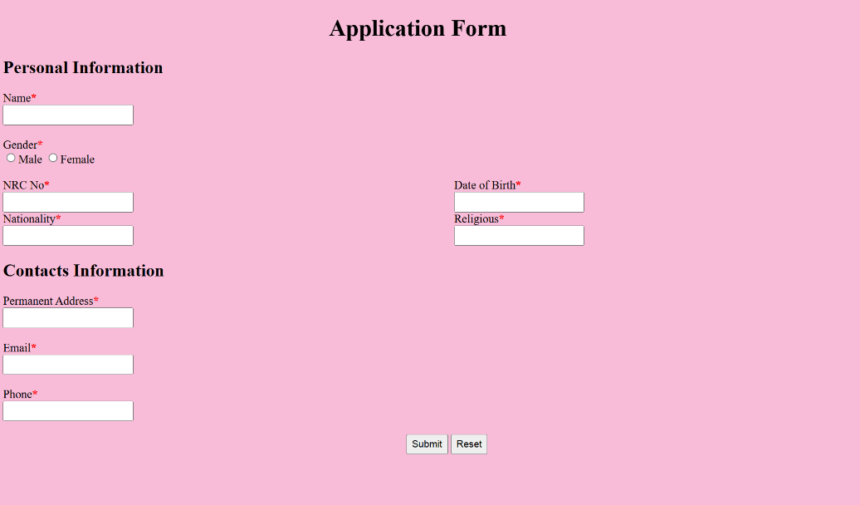
Step2.when the enter Name ,etc.. and click the submit button, the information is show.

Step3.when the Name box is blank, the next is show.

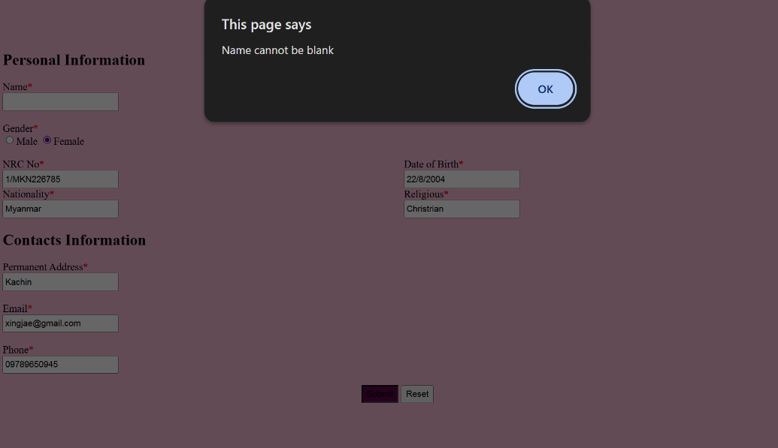
Step4. When click reset button ,the text boxes are clean
